Report on Assesing Infection:

**⚫Vital information:**

U10P32002, School of Computer Science and Technology, NPU, Spring 2019

Written by Dikshya Kafle

2018380039

Programming Assignment 5 Due date: 6th May

⚫**Problem Statement**:

The purpose of this assessment is to the understand the recursion method. Similarly, it is to understand and apply a divide and conquer approach to solving a problem. Therefore in order to achieve our goals in understanding of recursion and problem solving using a divide and conquer approach we have been provided with the four handout files named as grid.cpp, grid.h, main.cpp, sample.h. As a student my task is to finish the implementation of a program which assesses the level of infection in a tissue sample. We have been provided with the data which represents a rectangular tissue sample that is being covered with a grid. In addition to that, only some parts of the tissues are being infected and others are not affected. Thus, the program is to be written to be able to assess the extent of the infection. This allows the coordinates of a colony of infection to define its size. For this purpose we are supposed to update the class grid declaration in the file grid.h and update the class grid implementation.

**⚫ Structure Chart** :

row

grid

Main

ostream

col

count

grid

visited

area

string file

INFECTED

NOT_INFECTED

grid_file

indexof

infected

rows

blob_col

blob_row

colss

**⚫ Implementation**

In “main.cpp” : The file is not changed it remains the same as given in the handout of Assignment 7:

**int main**

**Name and types of parameters:** “ argc”-int, “argv[]”-char, “row”-int, “col”-int.

-argv and argc are how command line arguments are passed to main() in C++.

**Input:** coordinates of the cell in the grind is being entered. The number of rows and columns of the cell is being entered.

**Output:** If the enter cell doesn’t exist then the program fails to attempt returning to the exit failure. If the input is correct then the program will output “the colony including the cell at”, row, column, its area and units. Then returns success.



**Algorithm:** main.cpp has use one if statement to define the condition for the success and failure of the program. If the command line argument exists then the program is being run.

**grid.h:**

grid.h is a header file the extension ".h" contains C++ function declaration and macro definition.

Header file contains information (or declarations) for a particular group of functions.

**Names and types of any parameters:** “row”-int, “col”-int, “string file”-string, “ostream &stream, const grid& ob”

A function becomes const when const keyword is used in function’s declaration. In this program bool function is declared by using const. Therefore the const doesn’t allow the declared function to modify the object when they are called.

Class is a user defined data type, which holds its own data members and member functions, which can be accessed and used by creating an instance of that class. A class name grind has been declared in the **grind.h**. It contains two different modifiers i.e. private and public. A public member is accessible from anywhere outside the class but within the program. It is possible for user to set and get the value of public variables without any member. Whereas private member function cannot be accesses, or even viewed from outside the class. Only the class and friend functions can access private members.

**Therefore, in the private a new vector string function named visited is being declared which is to be accessed by the grid.cpp.**

***vector<string> *visited;***

**grid.cpp:**

**Names and types of parameters: int row,int col, (*area)[indexof(row, col)] == INFECTED), (string file), file.c_str(),rows*cols, NOT_INFECTED,** **ostream &stream, const grid&ob**

**Input:** The user interacts with the program only through command-line arguments. The programmer supplies to the data filename and the coordinates of a cell in the grid. The coordinates are specified by row and then column, both starting at zero.

**Output:** The program calculates the extent of infection at that specific coordinate and outputs a two-dimensional representation of the tissue as shown in the section of ***Test Description and Results.***

**Algorithm:**

Two vectors were introduced in grid.h. vector area with bool function and vector visited with string function.

Recursion is the name for the case when a function invokes itself or invokes a sequence of other functions, one of which eventually invokes the first function again.

bool function is being used to return true or false value. Similarly in the case of string 1 and 0 is used in expressing true or false. At first the number of rows and cols are being enter and found the no infected area and also not visited cells. Afterwards while statement is being used to see the result of area and visited while it was true. Therefore, as written in the code the area is infected in this condition and also the cell are being visited therefore it’s written:

**area->operator[](indexof(blob_row,blob_col)) = INFECTED;**

**visited->operator[](indexof(blob_row,blob_col)) = "1 ";**

After finding out the infected and non_infected cells and visited and non_visited cells the vector area and vector visited is being deleted.

The function needs to be altered in the following part in order to diplay the (+) sign next to the cells which belongs to the counted colony:

**ostream &operator<<(ostream &stream, const grid& ob) {**

**for (int row=0; row < ob.rows; row++)**

**{**

**for (int col=0; col < ob.cols; col++)**

**{**

**stream << ob.visited->operator[](ob.indexof(row, col));**

**}**

**stream << endl;**

**}**

**stream << endl;**

**return stream;**

**}**

Afterwards, the return statement in this function is being replace by the recursive implementation of this method.

**int grid::count (int row, int col) {**

**if(0<=row&&row < rows&&0<=col&&col < cols)**

**{**

**if(infected( row, col)&&visited->operator[](indexof(row,col)) =="1 ")**

**{**

**visited->operator[](indexof( row,col)) ="1+ ";**

**return 1+count (row+1, col+1)+count (row+1, col)+**

**count (row+1, col-1)+count (row, col-1)+**

**count (row , col+1)+count (row-1, col+1)+**

**count (row-1, col )+count (row-1, col-1);**

**}**

**}**

**else return 0;**

**}**

**⚫ Test Description and Results**:

The following is the result of the assessing infection program. I created a project in the code blocks and added grid.cpp where I had implemented codes file which I had written. Afterwards I opened an empty file on it and copied and pasted a file named main.cpp from the given assignment 7 handouts. Similarly, I did the same for file grid.h an updated grid.h file was added to the project. After adding all three files in the project. I opened the project folder and added the file sample.grind. After this I selected Set programs´ arguments … and I entered the command line arguments as shown in the picture.

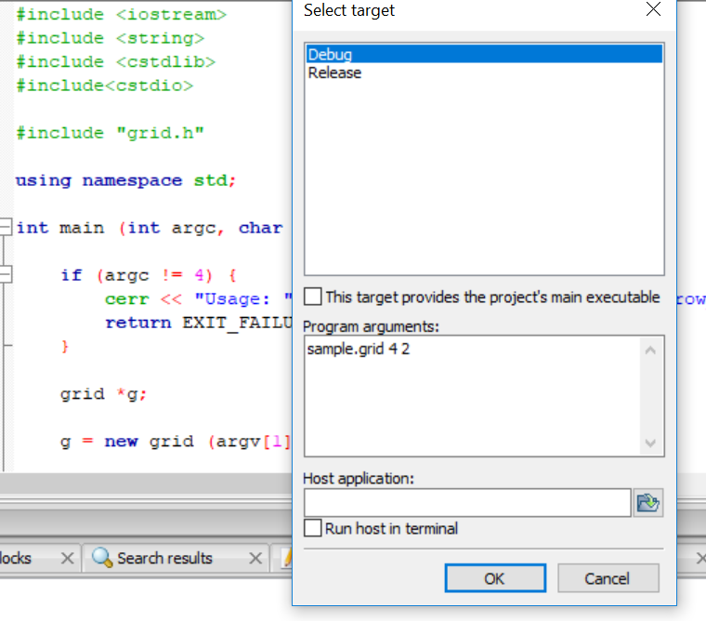

The following is the result of the program:

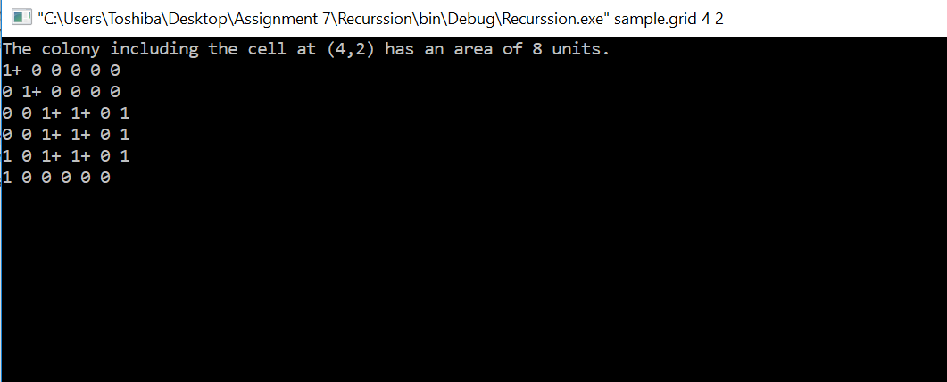

A typical use of the program follows. The user interacts with the program only through command-line arguments. The user supplies to the program a data filename and the coordinates of a cell in the grid. The coordinates are specified by row and then column, both starting at zero. The program calculates the extent of infection at that coordinate and outputs a two-dimensional representation of the tissue sample. Figure 1 depicts the execution of the program.

**⚫ Epilogue** – While doing the program I had many bugs which had influence on program’s working and many troubles with compilation programs, because of syntax. It was very difficult for me to understand what errors I made. Later I figured out I had kept the space between row,col and count which occurred problem in running the program. Therefore I corrected the statement as displayed in the following.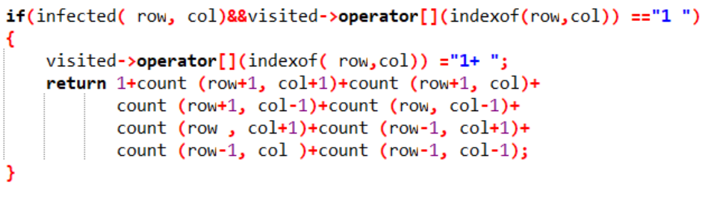 In the beginning I forgot to add file sample.grid to te project it also caused a bug in the program. In addition to that my code block started acting weird so I decided to uninstall and install it back again. After doing so I was finally able to run my codes properly and got the final results and I felt so much stressed relief at once. This program is too time consuming and I found that this topic is a very tough one. It was kind of confusing to understand and explain well. However, I managed to do deal all these bugs with the help of TA’s advice and with the help of a lot of You Tube videos, blogs and websites. This program helped me understand the concept of a recursive function. In addition to that, it also helped me to understand and apply a divide and conquer approach to solving a problem like this.

**⚫ Attachments**: The file grid.cpp and grid.h is being attached in the email. And this is the report file.

**⚫ Acknowledgement**: In the processes of solving this assignment I looked for a lot of information in the internet. I watched several videos related to recursion and took few notes in the process of understanding. I would like to thank You Tube and a lot of coding related websites for helping me understand what I have done in this report.